Assignment -1
ARDUINO UNO
Assignment Date | 19sept22
Student Name | chithambaram
Student roll no | 912419106003
Maximum marks | 2marks
Question-1:
1. Alarm should sound in one manner if temp is above 60C Solution:
CODE:
Void setup ()
{
Serial. Begin (9600);
Pin Mode (5, OUTPUT);
}
Void loop ()
{
Int data=analog Read (A0);
Double n=data/1024;
Double volt=n*6; Double off=volt-0.6; double temperature=off*100;
Serial.print (&quot;Temperature data :&quot;); Serial.println (temperature); Tone (5,100); delay (1000); tone (5,200); delay(1000);
}
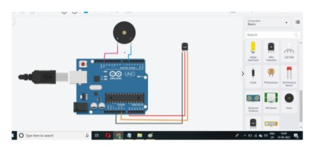
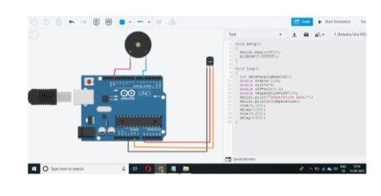
Question-2:
2. Alarm should sound with another frequency if motion is detected in PIR sensor
Solution:
Void setup ()
{
Pin Mode (2, INPUT);
PinMode(13, OUTPUT);
}
Void loop ()
{
if (digitalRead(2)==HIGH)
{
digitalWrite(13, HIGH);
}
else
{
digitalWrite (13, LOW);
}
Delay (10); // Wait for 1000 millisecond(s)
}

